200W Beam Moving Head

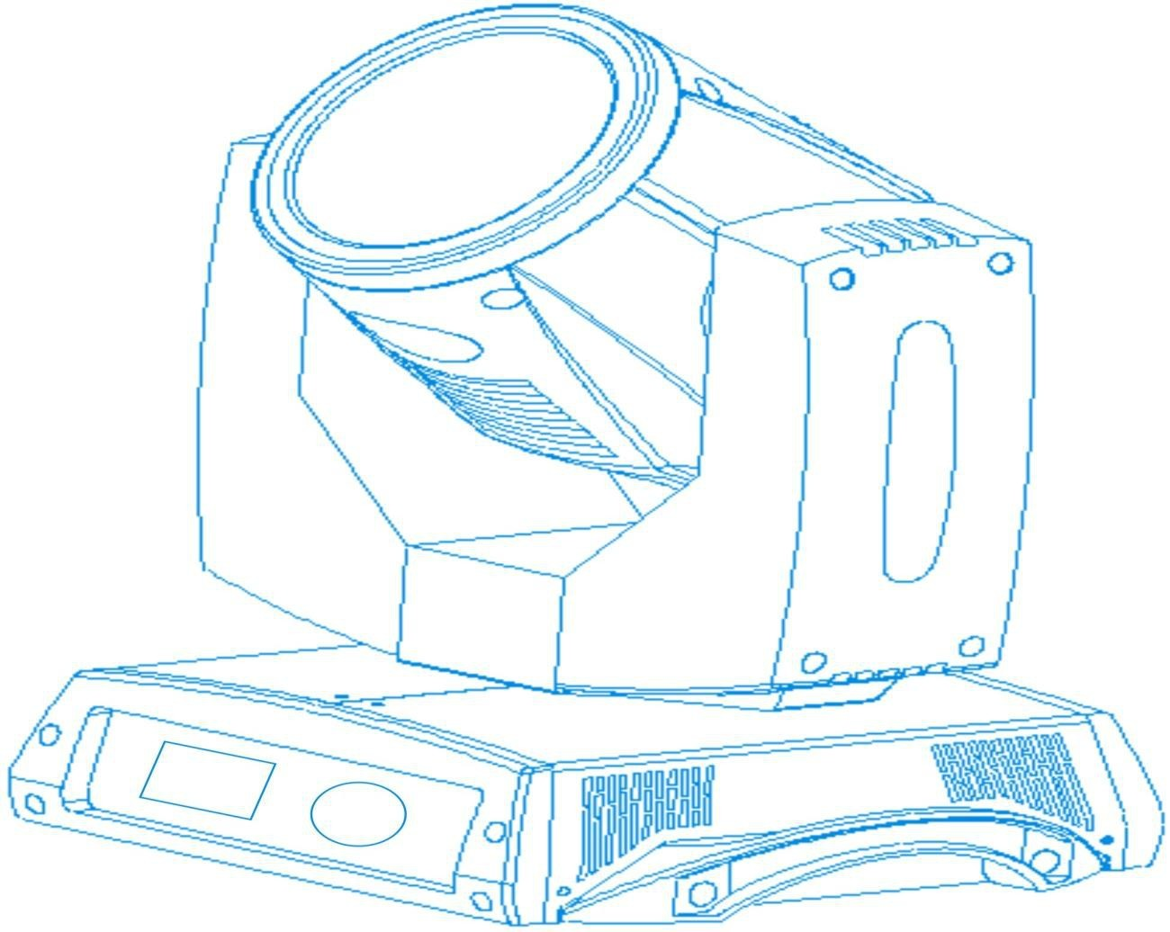

Please read the manual carefully before using

Contents

1 Operation Mode
2 Interface Introductions
3 Channel Modes
4 Function Reference
5 Securities
6 Caution

- Operation Introduction
Touching | Runner | Function
Up Button | turn right | select/edit
Down Button | turn left | select/edit
Enter Button (OK Button) | press the runner | function running edit opening edit escape
Back Space key | press the runner on the back menu | return to the ad menu

To take a "modify the DMX address number" example for explain the function of touching:
1Touch Settings button in the main interface, enter the setup interface
2 Right side of the four touch buttons are "on", "down", "return"
3 Press the Up or Down keys, select dmx address code
4 Press the OK button to edit
5 Press the OK button to modify the DMX address (immediate save and apply the new
address automatively
6 Press the Enter key to esc edit state (or this step can be omitted)
7 Press the Backspace key to return to the main menu

If using a wheel, then the process is as follows
1 In the main interface, turn the runner, select Set Up button
2 Press the wheel and then release into the setting interface
3 In the Setting interface, turn the wheel, select DMX Address
4 Press the wheel and then release into the setting interface
5 Turn the wheel to esc edit state
6 After modify the address code, press the wheel then release to esc edit state
7Turn the wheel to select return, press the button and then release back to the main interface
2. Interface Setting
1) Master Interface
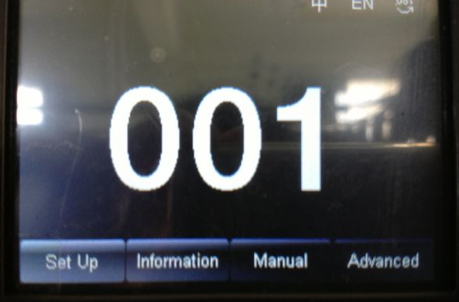
Top right corner of the three buttons are for language switching and screen rotating.
The bottom of four buttons corresponding sub-interface should see below.

The functions of sub-interface are mainly about touch key, and if you choose runner, the corresponding relationship are as follows:
Press "up" key: turn left
Press "down" key: turn right
Press "enter" key: turn down the wheel

Dialogue box of the runner operation
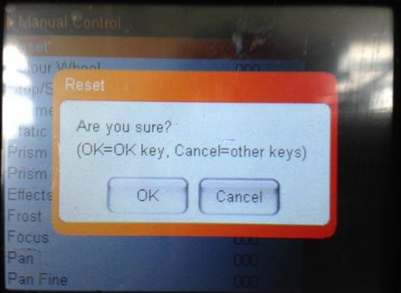

Press “enters" to turn down the wheel. Press "cancel" if not.
2) Interface setting
Option | Information
Operation Mode | DMX | Slave state: receive the DMX signal
Operation Mode | Automation | Master state: operate automatively, sending DMX signal to slave  Caution: You can check light effect only when the light on and enter an automatic state
DMX Address | 1~512 | Press “Enter” to edit. select hundred, press “up” ”down” to modified the address. Press “Enter “to select decade to edit. One more time to press
Channel Mode | 15
Channel Mode | 18
X Reverse | ON/OFF
Y Reverse | ON/OFF
XY Reverse | ON/OFF
XY Exchange | OFF
XY Exchange | ON | To exchange XY channel(including detail correct)
XY Encoder | ON | Check the missing step by optocoupler and correct.
XY Encoder | OFF | Correct the position without using the optocoupler.
Non-signal DMX | Save | Operate under the original state
Non-signal DMX | Clear | Reset motor, stop working
Screen Protection | ON | Backlight off after 30s vacant
Screen Protection | OFF | Keep lighting under backlight
Lighting Boot | ON | Light on as soon as the power on, then reverse
Lighting Boot | OFF | Reverse as soon as the power on(use the menu or console to light up)
Default Setting Recovery |  | Press “Enter” to check the dialogue, then press “Enter” to recover default setting

- Information Interface

Option | Information
Software | The newly version
Total Time | Total using time(accurate to minute)
Single Time | Total time for single using(accurate to minute)
DMX Channel Value | Check the channel value and percentage under this sub-interface
System error Record | If the red light ERR sparks, you should check the detail information by enter sub-interface cause the device must went something wrong

4) Function Reference
This is only for controlling the device, not belong to the slave state(do not receive DMX signal),neither the master state(do not send DMX signal)
Option | Information
Reset | Press “Enter” to check the dialogue, press “Enter” again to enter reverse interface, all the motor will reverse
Color Wheel | 0~255 | Press “Enter” to edit. Press “up””down” to change channel value when select hundred position. Press “Enter” again to select decade to edit.The same way to edit individual value. One more time press “Enter” to exit
…… | 0~255
Gobo wheel Speed | 0~255
Lamp Control | ON
Lamp Control | OFF

5)Advanced Interface
The code “up””down””up””down” respond to wheel “left””right””left””right”
Touching Process: First time press “up” button (the first”*” display), the second time press “up” button(the second “*” display), the third time to show “*” is the same. Finally to press “Enter “to verify the password
Rotate Wheel Process: Right turn forward (the first “*” display), left turn backward (the second “*” display), the third time to show “*” in the same way to step 1, the forth time to show “*”in the same way to step 2.Finally press the wheel to verify the password.

Option | Information
Touching screen test | Enter testing interface, touch the place according to the cross mark until receive OK respond 4 times.In case of testing failure and the endless process, press “Enter” to exit.
Reverse Test | When enter sub-interface, adjust the XY motor reverse position to lessen the hardware mistakes.  You have to edit one by one for single step cause it is different from address and channel value.  Caution: you are not suggest to test when the motor is working.  If it is necessary, please reverse the device before testing.

- Channel Modes
1 | Color Wheel | Color Wheel
2 | Light Cut/Strobe | Light Cut/Strobe
3 | Dimmer | Dimmer
4 | Gobo Wheel | Gobo Wheel
5 | Prism | Prism
6 | Prism Rotate | Prism Rotate
7
8 | Atomization mirror | Atomization mirror
9 | Focus | Focus
10 | X axis | X axis
11 | X Fine tuning | X Fine tuning
12 | Y axis | Y axis
13 | Y Fine tuning | Y Fine tuning
14 | XY Speed | XY Speed
15 | Reverse | Reverse
16 | Lamp Control | Lamp Control
17 |  | Gobo Wheel/Speed
18 |  | Dimmer-Prism-Atomization Speed

4. Function Reference
Channel 1
DMX Value | Effect | Remark
255 | Brightness100
…… | ……
0 | Brightness0

Channel 2
DMX Value | Effect | Remark
252-255 | Light Shut | Combination Channel 1
239-251 | Radom Fast Strobe
266-238 | Radom Normal Strobe
213-225 | Radom Slow Strobe
208-212 | Shutter On | Combination Channel 1
207 | Pulse Fast Strobe
…… | ……
108 | Pulse Slow Strobe
104-107 | Shutter On | Combination Channel 1
103 | Fast Strobe
…… | ……
4 | Slow Strobe
0-3 | Shutter Off

Channel 3
DMX Value | Effect | Remark
255 | Fast Rotating | All of the color value is designed to be the multiple of 5, so that easy to remember. The percentage can be adjust, example: When display shows 5 that means white 50%, dark red 50%. When it shows 4, that means white 40%, dark red 60%.
…… | ……
150 | Slow Rotating
145 | Brown+White
…… | ……
5 | White+Red
0 | White

Channel 4
DMX Signal Value | Effect | Remark
255 | Gobo17 Shack Fast | Every 5 gobo response to one gobo
…… | …… | Every 5 gobo response to one gobo
251 | Gobo17 Shack Slow | Every 5 gobo response to one gobo
175 | Gobo1 Shack Fast | Every 5 gobo response to one gobo
…… | …… | Every 5 gobo response to one gobo
171 | Gobo1 Shack Slow | Every 5 gobo response to one gobo
170 | Fast Rotating(Forward)
…… | ……
135 | Slow Rotating(Reverse)
130-134 | Stop(White)
129 | Slow Rotating(Reverse)
…… | ……
90 | Fast Rotating(Reverse)
85 | Gobo17 | The value would be Multiples of 5
…… | …… | The value would be Multiples of 5
5 | Gobo1 | The value would be Multiples of 5
0 | White | The value would be Multiples of 5
Channel 5
DMX Value | Effect | Remark
128-255 | Insert Prism
0-127 | Remove Prism

Channel 6
DMX Value | Effect | Remark
255 | Rotating Fast(Forward)
…… | ……
193 | Rotating Slow(Forward)
191-192 | Stop
190 | Rotating Slow(Reverse)
…… | ……
128 | Rotating Fast(Reverse)
0-127 | Prism Angle Adjust

Channel 8
DMX Value | Effect | Remark
128-255 | Atomization
0-127 | Non-atomization

Channel 9
DMX Value | Effect | Remark
255 | Dimmer100
……. | ……
0 | Dimmer0
Channel 10
DMX Value | Effect | Remark
255 | Pan Movement 540
…… | ……
0 | Pan Movement 0

Channel 11
DMX Value | Effect | Remark
255 | Pan set accuracy 100
…… | ……
0 | Pan set accuracy 0
Channel 12
DMX Value | Effect | Remark
255 | Tilt Movement270
…… | ……
0 | Tilt Movement0

Channel 13
DMX Value | Effect | Remark
255 | Tilt set accuracy 100%
...... | ……
0 | Tilt set accuracy 0%

Channel 14
DMX Value | Effect | Remark
255 | Pan/Tilt run in fast speed
…… | ……
0 | Pan/Tilt run in fast speed
Channel 15
DMX Value | Effect | Remark
128-255 | Reset All the Motor | Reset the device after staying at the state for 5 seconds
77-127 | Reset Main Motor(XY) | Reset the device after staying at the state for 5 seconds
26-76 | Reset Individual Motor | Reset the device after staying at the state for 5 seconds
0-25 | Non-Valid Area | Reset the device after staying at the state for 5 seconds

Channel 16
DMX Value | Effect | Remark
101-255 | Turn On the Lamp | Operate the device after staying at the state for 5 seconds
10-100 | Turn Off the Lamp | Operate the device after staying at the state for 5 seconds
5 Security
1. Please never try to project the beam onto substances for a long time to avoid getting fire. For this device is high light temperature product.
2. In order to the consumer’s profit and ensure the long life time of the device, we suggest that keep it dry in working during -20~30 temperature.
3. This is for situation the power is on and when the device is not indeed. Do not operate the device under dark mode for more than 20 minutes. You should first use the 14 channel under the third channel mode to turn off the light.(Please remind the lamp will be lighted up after 10 minutes when it was just turn off.)
4. The device needs about 20 minutes to be cooled after the power off.
5. Operate the device only after having familiarized with its functions. Do not permit operation by persons not qualified for operating the device. Most damages are the result of unprofessional operation.
6. Use the professional fitting when the device needs to be hanging up or change the details. Please contact relate factory if you can’t get the fitting.
6 Caution
After connect to Power Supply,Operate up to 255 on Channel 16 with DMX Controller,Then the lamp will be ON gradually. (Operate the device after staying at the state for 5 seconds.)
You can also set up "Burn on startup" on the touch screen on the light device.

